SET 6 – Product Sales Analysis Dataset
Product ID | Product Name | January Sales | February Sales | March Sales
1 | Product A | 2000 | 2200 | 2400
2 | Product B | 1500 | 1800 | 1600
3 | Product C | 1200 | 1400 | 1100
Aim
To analyze monthly product sales using grouped bar charts, stacked area charts, tables, and a Tableau dashboard.

Q1. Grouped Bar Chart – First Quarter Sales
Program Name: Quarterly Product Sales Grouped Bar Chart
product <- c("Product A", "Product B", "Product C")

sales <- matrix(c(2000, 2200, 2400,
1500, 1800, 1600,
1200, 1400, 1100),
nrow = 3,
byrow = TRUE)

barplot(sales,
beside = TRUE,
names.arg = c("January", "February", "March"),
main = "First Quarter Product Sales",
xlab = "Month",
ylab = "Sales",
legend.text = product)
Observation:
Product A has the highest sales in all three months. Product C has the lowest sales in March.
Output:
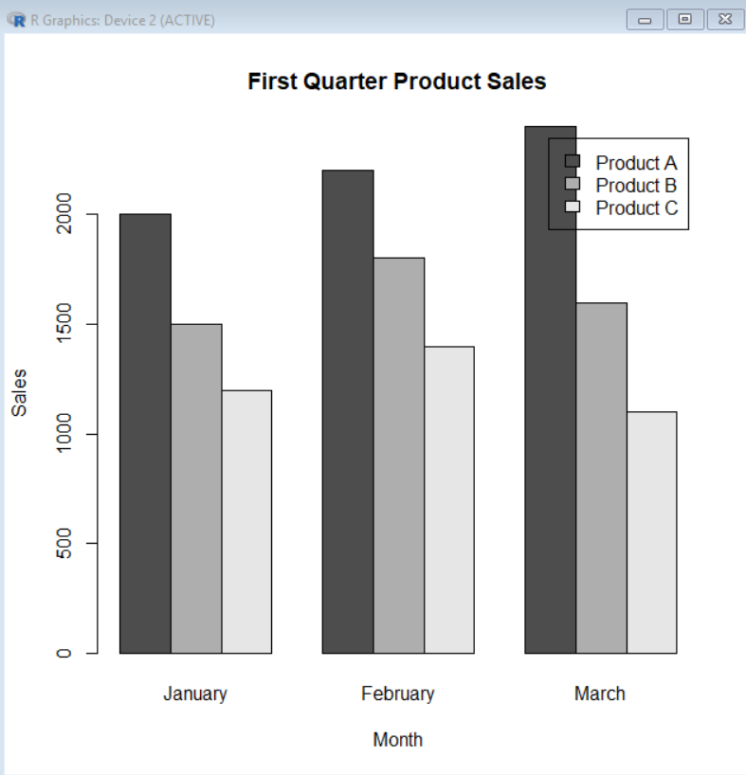

Q2. Stacked Area Chart – Overall Sales Trend
Program Name: Monthly Product Sales Stacked Area Chart
month <- 1:3

product_A <- c(2000, 2200, 2400)
product_B <- c(1500, 1800, 1600)
product_C <- c(1200, 1400, 1100)

total <- product_A + product_B + product_C

plot(month, total,
type = "o",
main = "Overall Product Sales Trend",
xlab = "Month",
ylab = "Total Sales",
xaxt = "n")

axis(1, at = 1:3,
labels = c("January", "February", "March"))
For a true stacked-area display, you can use:
sales <- rbind(product_A, product_B, product_C)

library(ggplot2)

df <- data.frame(
Month = rep(c("January", "February", "March"), 3),
Product = rep(c("Product A", "Product B", "Product C"), each = 3),
Sales = as.vector(sales)
)

ggplot(df, aes(x = Month, y = Sales, fill = Product, group = Product)) +
geom_area() +
labs(title = "Stacked Area Chart of Product Sales",
x = "Month",
y = "Sales")
Observation:
Overall sales increase from January to February and reach the highest total in March mainly because of Product A.
Output:
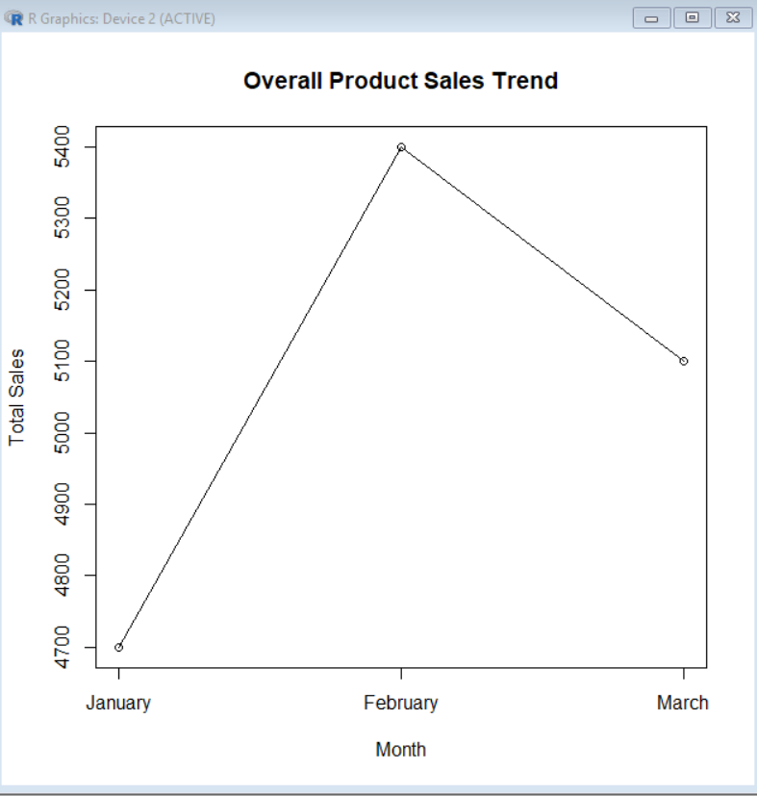

Q3. Table – Monthly Sales Data
Program Name: Monthly Product Sales Table
sales_data <- data.frame(
Product = c("Product A", "Product B", "Product C"),
January = c(2000, 1500, 1200),
February = c(2200, 1800, 1400),
March = c(2400, 1600, 1100)
)

print(sales_data)
Observation:
The table clearly presents the sales of each product for January, February, and March.
Output:
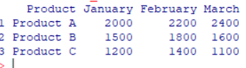

Q4. Tableau Dashboard
Program Name: Product Sales Analysis Dashboard
Procedure:
- Open Tableau.
- Import the Monthly Product Sales dataset.
- Create a grouped bar chart.
- Create a stacked area chart.
- Create a sales table.
- Create a new dashboard.
- Drag all three worksheets into the dashboard.
- Add filters for product and month.
- Format the dashboard.
Observation:
The dashboard combines product comparison, sales trends, and detailed monthly sales data in one interactive view.
Overall Procedure – Set 6
- Enter the monthly sales dataset.
- Create a grouped bar chart.
- Create a stacked area chart.
- Create a sales table.
- Import the data into Tableau.
- Create three worksheets.
- Combine them into a single dashboard.
- Add interactive filters.
Result
The monthly product sales were successfully visualized using grouped bar charts, stacked area charts, and tables. A Tableau dashboard was developed for interactive sales analysis.

